**OverTheWire: Bandit**

**Level 0**:-

**Login Command**:- ssh bandit0@bandit.labs.overthewire.org -p 2220

**Password of this level:** bandit0

**Screenshot(Next Level Password):**

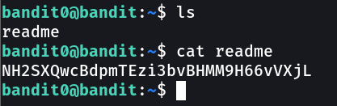

**_______________________________________________________________________________________**

**Level 1**:-

**Login Command**:- ssh bandit1@bandit.labs.overthewire.org -p 2220

**Password of this level:** NH2SXQwcBdpmTEzi3bvBHMM9H66vVXjL

**Screenshot(Next Level Password):**

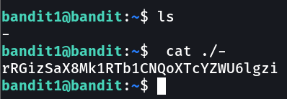

**_______________________________________________________________________________________**

**Level 2**:-

**Login Command**:- ssh bandit2@bandit.labs.overthewire.org -p 2220

**Password of this level:** rRGizSaX8Mk1RTb1CNQoXTcYZWU6lgzi

**Screenshot(Next Level Password):**

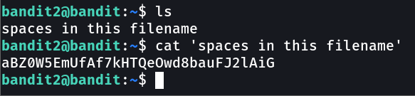

**_______________________________________________________________________________________**

**Level 3**:-

**Login Command**:- ssh bandit3@bandit.labs.overthewire.org -p 2220

**Password of this level:** aBZ0W5EmUfAf7kHTQeOwd8bauFJ2lAiG

**Screenshot(Next Level Password):**

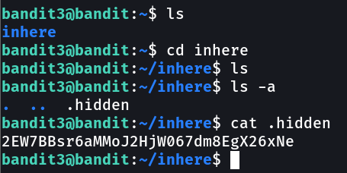

**_______________________________________________________________________________________**

**Level 4**:-

**Login Command**:- ssh bandit4@bandit.labs.overthewire.org -p 2220

**Password of this level:** 2EW7BBsr6aMMoJ2HjW067dm8EgX26xNe

**Screenshot(Next Level Password):**

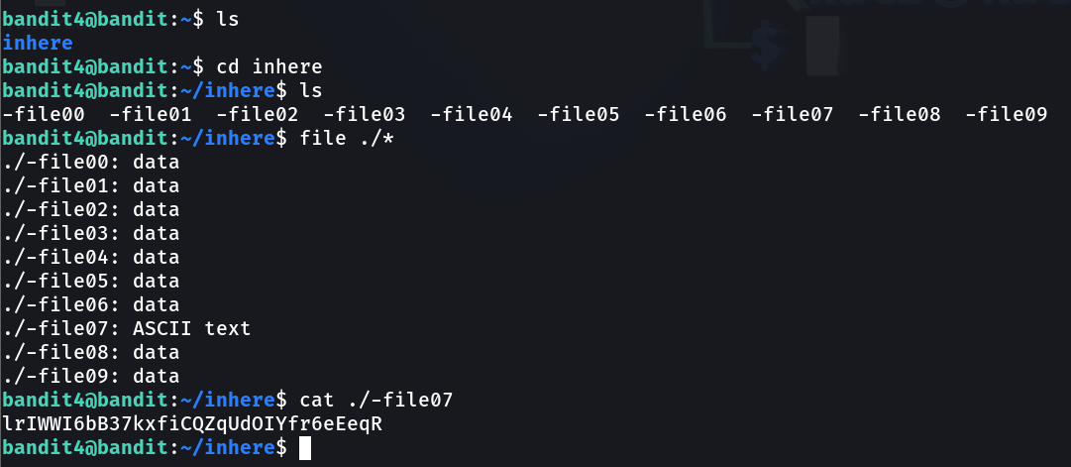

**_______________________________________________________________________________________**

**Level 5**:-

**Login Command**:- ssh bandit5@bandit.labs.overthewire.org -p 2220

**Password of this level:** lrIWWI6bB37kxfiCQZqUdOIYfr6eEeqR

**Screenshot(Next Level Password):**

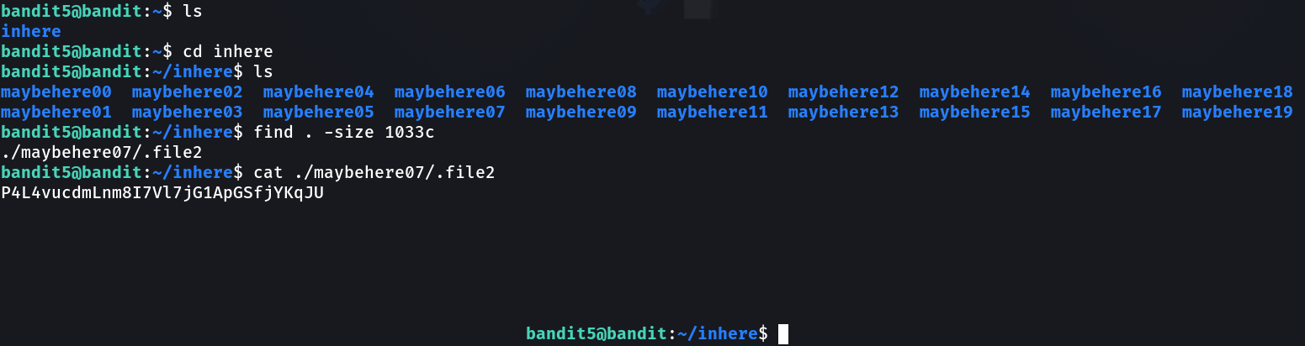

**­­­­­­­­­­­­­­­_______________________________________________________________________________________**

**Level 6**:-

**Login Command**:- ssh bandit6@bandit.labs.overthewire.org -p 2220

**Password of this level:** P4L4vucdmLnm8I7Vl7jG1ApGSfjYKqJU

**Screenshot(Next Level Password):**

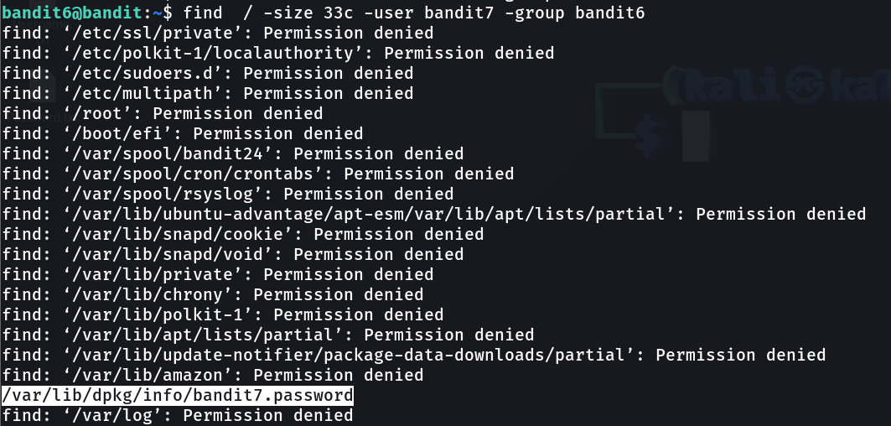

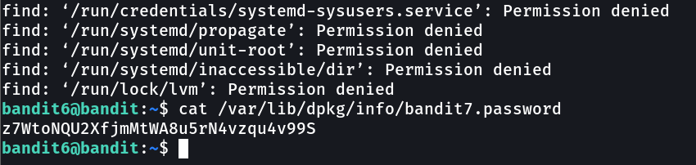

**­­­­­­­­­­­­­­­_______________________________________________________________________________________**

**Level 7**:-

**Login Command**:- ssh bandit7@bandit.labs.overthewire.org -p 2220

**Password of this level:** z7WtoNQU2XfjmMtWA8u5rN4vzqu4v99S

**Screenshot(Next Level Password):**

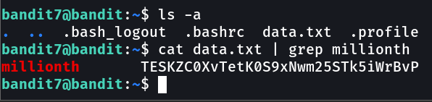

**­­­­­­­­­­­­­­­_______________________________________________________________________________________**

**Level 8**:-

**Login Command**:- ssh bandit8@bandit.labs.overthewire.org -p 2220

**Password of this level:** TESKZC0XvTetK0S9xNwm25STk5iWrBvP

**Screenshot(Next Level Password):**

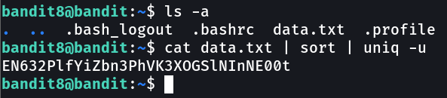

**­­­­­­­­­­­­­­­_______________________________________________________________________________________**

**Level 9**:-

**Login Command**:- ssh bandit9@bandit.labs.overthewire.org -p 2220

**Password of this level:** EN632PlfYiZbn3PhVK3XOGSlNInNE00t

**Screenshot(Next Level Password):**

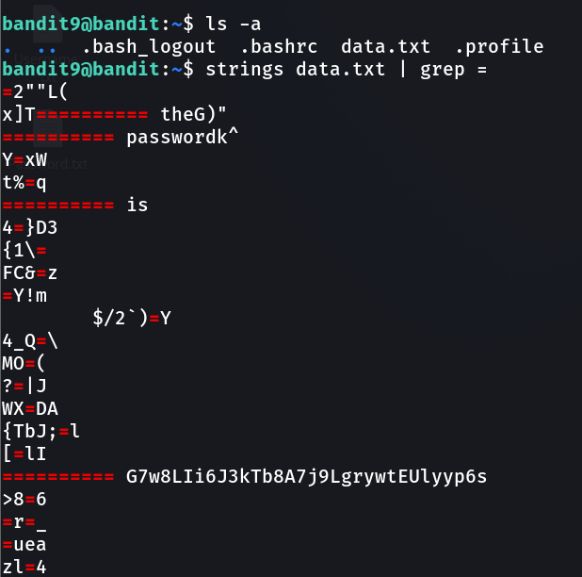

**­­­­­­­­­­­­­­­_______________________________________________________________________________________**

**Level 10**:-

**Login Command**:- ssh bandit10@bandit.labs.overthewire.org -p 2220

**Password of this level:** G7w8LIi6J3kTb8A7j9LgrywtEUlyyp6s

**Screenshot(Next Level Password):**

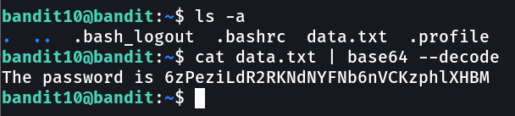

**­­­­­­­­­­­­­­­_______________________________________________________________________________________**

**Level 11**:-

**Login Command**:- ssh bandit11@bandit.labs.overthewire.org -p 2220

**Password of this level:** 6zPeziLdR2RKNdNYFNb6nVCKzphlXHBM

**Screenshot(Next Level Password):**

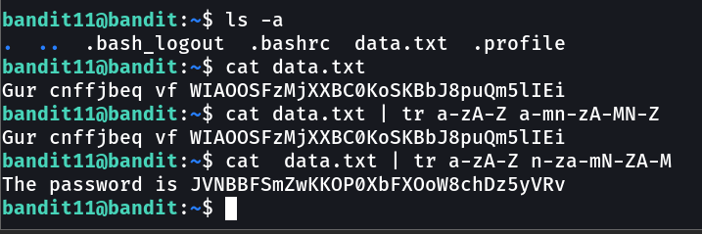

**­­­­­­­­­­­­­­­_______________________________________________________________________________________**

**Level 12**:-

**Login Command**:- ssh bandit12@bandit.labs.overthewire.org -p 2220

**Password of this level:** JVNBBFSmZwKKOP0XbFXOoW8chDz5yVRv

**Screenshot(Next Level Password):**

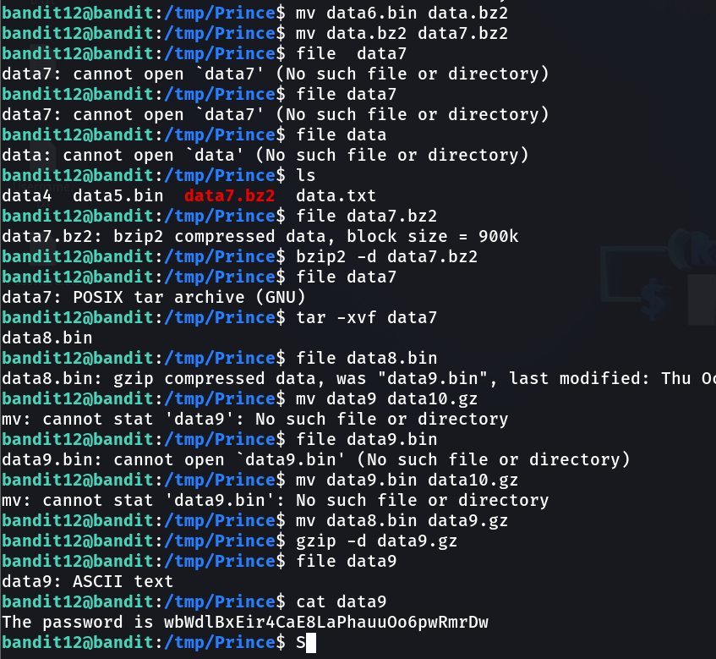

**­­­­­­­­­­­­­­­_______________________________________________________________________________________**

**Level 13**:-

**Login Command**:- ssh bandit13@bandit.labs.overthewire.org -p 2220

**Password of this level:** wbWdlBxEir4CaE8LaPhauuOo6pwRmrDw

**Screenshot(Next Level Password):**

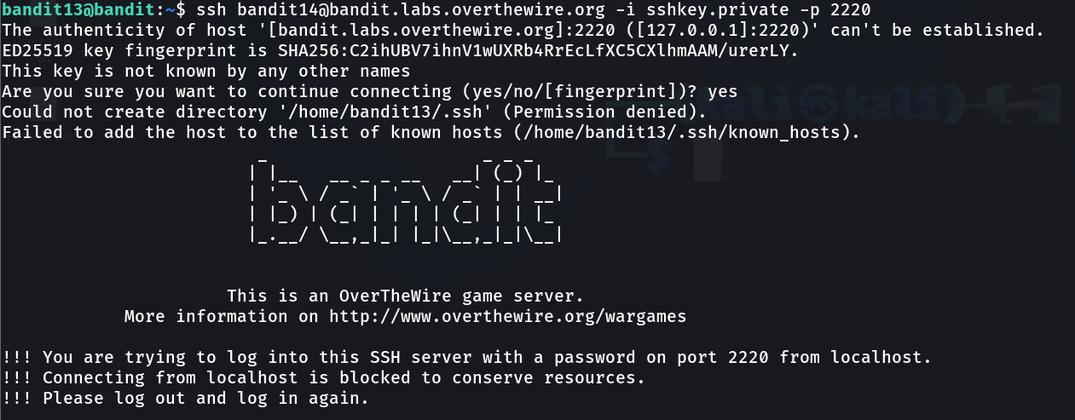

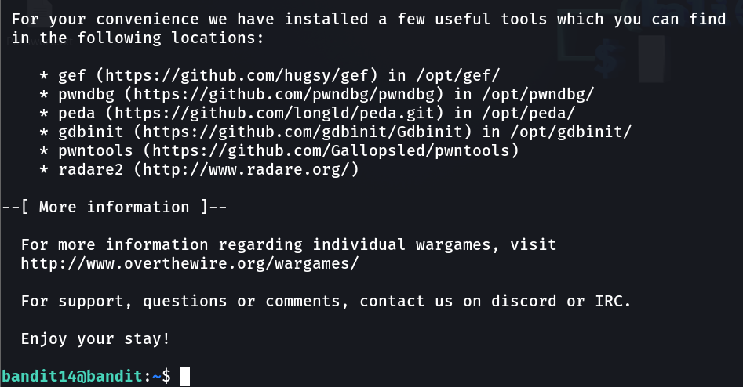

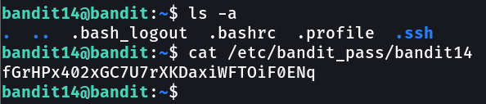

**­­­­­­­­­­­­­­­_______________________________________________________________________________________**

**Level 14**:-

**Login Command**:- ssh bandit14@bandit.labs.overthewire.org -p 2220

**Password of this level:** fGrHPx402xGC7U7rXKDaxiWFTOiF0ENq

**Screenshot(Next Level Password):**

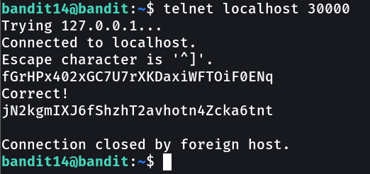

**­­­­­­­­­­­­­­­_______________________________________________________________________________________**

**Level 15**:-

**Login Command**:- ssh bandit15@bandit.labs.overthewire.org -p 2220

**Password of this level:** jN2kgmIXJ6fShzhT2avhotn4Zcka6tnt

**Screenshot(Next Level Password):**

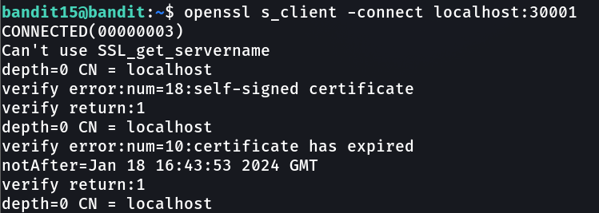

**_______________________________________________________________________________________**

**Level 16**:-

**Login Command**:- ssh bandit16@bandit.labs.overthewire.org -p 2220

**Password of this level:** JQttfApK4SeyHwDlI9SXGR50qclOAil1